8. Distributed Database Design

CockroachDB
CockroachDB is a distributed SQL database that is designed for cloud applications. It works like traditional SQL (PostgreSQL-style) but scales horizontally.

Key Benefits
1. Horizontal Scalability
- Easily scale by adding more nodes.
- No need to upgrade a single powerful server.
- Handles large-scale systems smoothly.
2. High Availability
- Data is automatically replicated across multiple nodes.
- If one node fails, system keeps running.
- Built-in fault tolerance.
3. Distributed Architecture
- Data is spread across different machines/regions.
- Enables global applications with low latency.
4. Fault Tolerance & Self-Healing
- Automatically recovers from failures.
- Rebalances data without manual intervention.
5. SQL Support (Easy to Learn)
- Uses familiar SQL (like PostgreSQL)
- Easy for developers to adopt.
6. Geo-Distribution
- Store data closer to users worldwide.
- Improves performance and user experience.

Schema
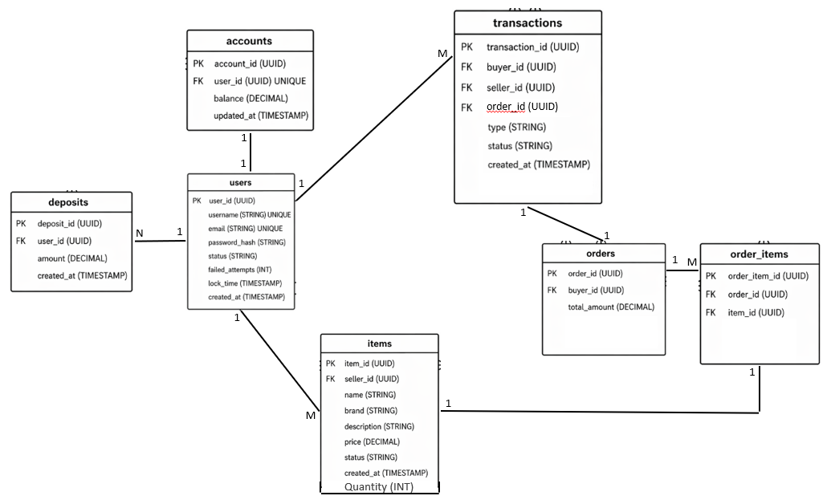

Partitioning Diagram
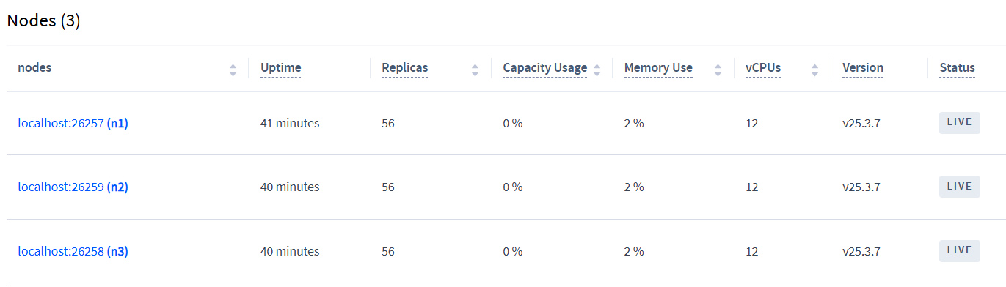
- Each table may be split into many ranges of rows each of 64MB or less according to traffic load.
- Each range is replicated in the 3 nodes.
- Automatically number of ranges (Chunks) are dynamically managed by cockroach DB itself according to traffic load or failed nodes.
- Horizontal partitioning
- Shard key is the primary key of each table so that avoid hot nodes to balance the traffic.

Database Architecture Diagram
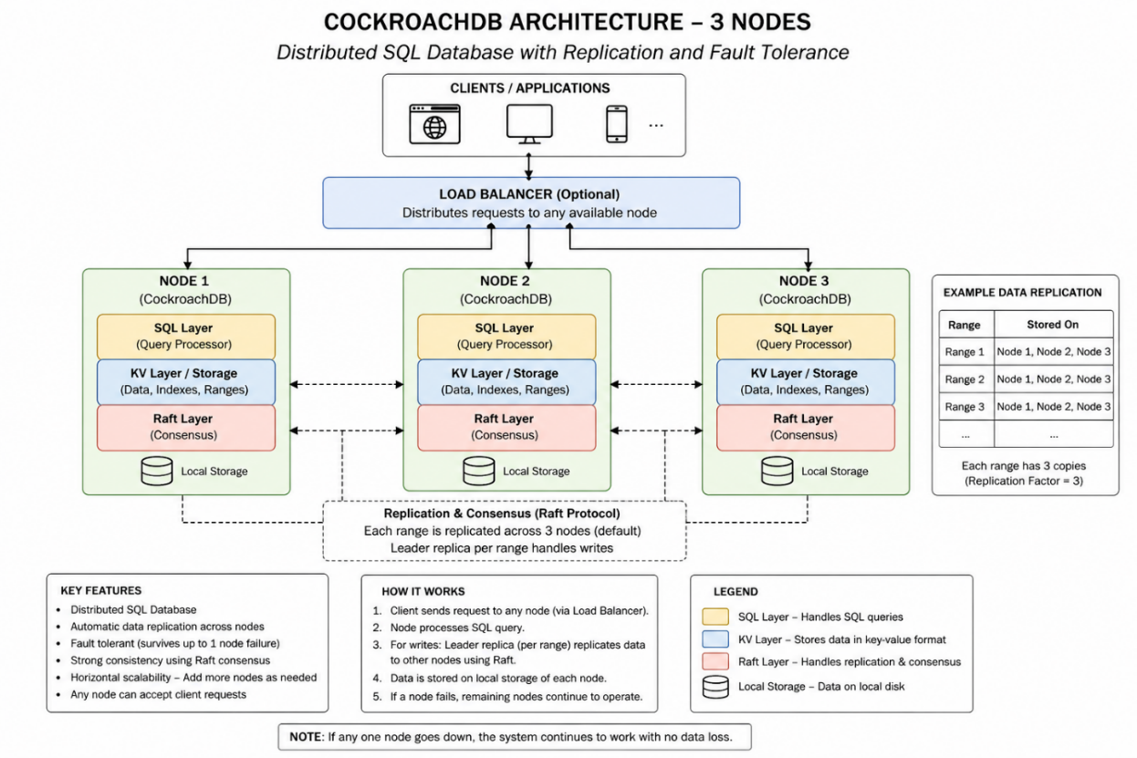
- KV is shortcut for key value indices storage for fast search.
- Raft layer manages the replications between nodes in which the two nodes must agree for the update or insertion for successful query

